**CSA0961 JAVA TEST (26-07-2024)**

**1.** **class Counter {**

**private int count = 0;**

**public void increment() {**

**count++;**

**}**

**public int getCount() {**

**return count;**

**}**

**}**

**public class Test {**

**public static void main(String[] args) {**

**Counter counter = new Counter();**

**while (counter.getCount() < 10) {**

**counter.increment();**

**}**

**System.out.println("Counter reached: " + counter.getCount());**

**}**

**}**

**2.** **class Employee {**

**private String name;**

**public Employee(String name) {**

**this.name = name;**

**}**

**public String getName() {**

**return name;**

**}**

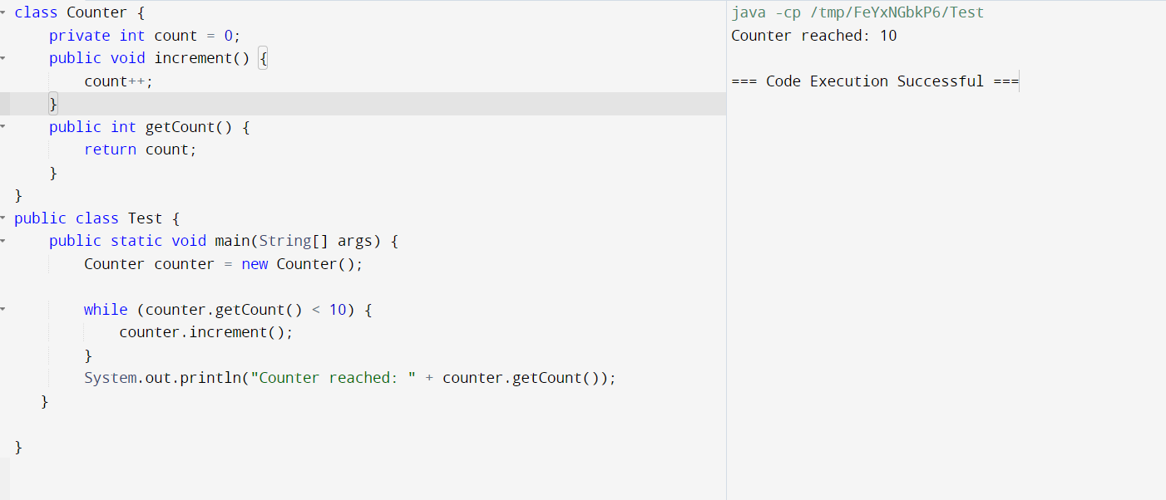

**}**

**public class Main {**

**public static void main(String[] args) {**

**Employee e = new Employee("John");**

**System.out.println(e.getName());**

**}**

**}**

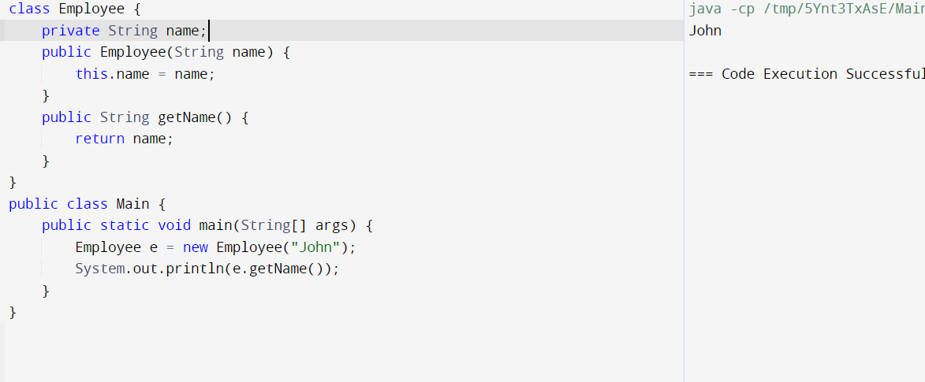

**3.** **import java.io.BufferedReader;**

**import java.io.FileNotFoundException;**

**import java.io.FileReader;**

**import java.io.IOException;**

**class FileOpener {**

**public void openFile(String filePath) {**

**try {**

**FileReader fileReader = new FileReader(filePath);**

**BufferedReader br = new BufferedReader(fileReader);**

**String line;**

**while ((line = br.readLine()) != null) {**

**System.out.println(line);**

**}**

**br.close();**

**} catch (FileNotFoundException e) {**

**System.out.println("File not found: " + filePath);**

**} catch (IOException e) {**

**e.printStackTrace();**

**}**

**}**

**}**

**public class TestFileOpener {**

**public static void main(String[] args) {**

**FileOpener opener = new FileOpener();**

**opener.openFile("missingfile.txt");**

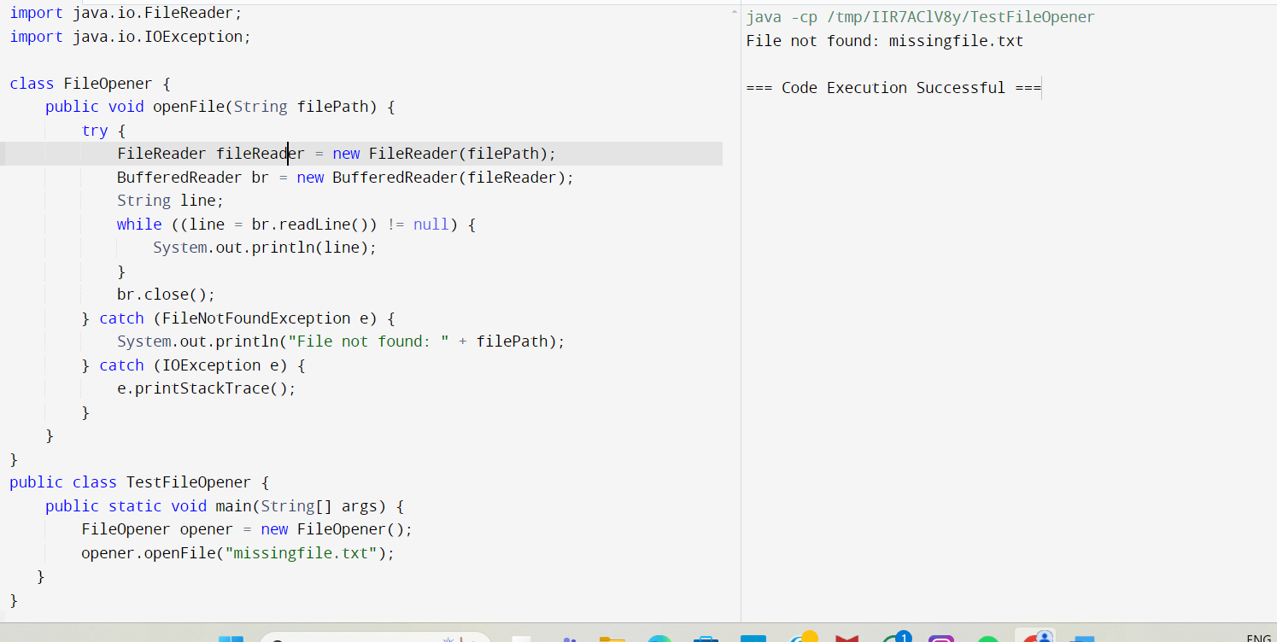

**}**

**}**

**4.** **public class PrintArray {**

**public static void main(String[] args) {**

**int[] numbers = new int[3];**

**numbers[0] = 10;**

**numbers[1] = 20;**

**numbers[2] = 30;**

**for (int num : numbers) {**

**System.out.println(num);**







